Part VI: Statistical analyses in R
The focus thusfar has been on data exploration, data manipulation, and description of data using basic statistics. In this part we start using the basic installation of R to run some well-known statistical models. The focus here is on the workflow for doing analyses and how to report the outcome of these analyses in a report or presentation.

Chapter 14. Basic statistical models in R
Also when we start doing statistical models, the first emphasis is on data exploration, including plotting, using the approaches we have been using before. As a general rule, you need to be sure your data is imported correctly. Furthermore, exploration of data using tabulation and quick plots will provide important background information that guides you towards constructing and interpreting statistical test. Directly running a test on data usually is a bad idea that easily leads to spurious findings.
The workflow is illustrated here in considering a few classical statistical models.

14.1 Chi-square test
The chi square test is used for frequency data (count data) across factorial levels. The objective of the test is to compute the probability (P value) that deviations between the observed and expected counts are due to chance alone. For clarity the data is here directly typed in R whereas typically you would hopefully have more data and would read in the data from a file prepared in a spreadsheet program. Remember therefore, the basics of reading in data from file: first read in the data using the appropriate version of read.table() and after that check the data using functions like summary(), head(), and str() to verify the data was read correctly into R.
Let’s consider an example. You want to study the extent that wind power turbines kill birds. To this end, you plan to search for carcasses of birds under the wind turbine. However, you first need to make sure you can find birds under the wind turbine. It turns out that under the wind turbines that you are to study there are two types of substrate: gravel or billbery bushes. You expect that finding a potential victim of a collision with a wind turbine will be much easier on a gravel plain than in the billberry bushes. To study this issue, you have a colleague place a rubber toy resembling a bird in either the gravel or the billberry and you search for it. You repeat this 20 times for each substrate. The data you obtain is contained in the following data.frame
> data.windturbine<-data.frame(trial=1:40
+ , substrate=c(rep("gravel",20),rep("billberry",20))
+ , found=c("yes","yes","yes","yes","yes","yes","no","yes","yes","yes","yes","no","yes","yes","yes","yes","yes","no","yes","yes"
+ ,"yes","no","no","yes","no","no","no","yes","yes","no","yes","no","no","yes","no","no","yes","no","yes","no"))
> data.windturbine
trial substrate found
1 1 gravel yes
2 2 gravel yes
3 3 gravel yes
4 4 gravel yes
5 5 gravel yes
6 6 gravel yes
7 7 gravel no
8 8 gravel yes
9 9 gravel yes
10 10 gravel yes
11 11 gravel yes
12 12 gravel no
13 13 gravel yes
14 14 gravel yes
15 15 gravel yes
16 16 gravel yes
17 17 gravel yes
18 18 gravel no
19 19 gravel yes
20 20 gravel yes
21 21 billberry yes
22 22 billberry no
23 23 billberry no
24 24 billberry yes
25 25 billberry no
26 26 billberry no
27 27 billberry no
28 28 billberry yes
29 29 billberry yes
30 30 billberry no
31 31 billberry yes
32 32 billberry no
33 33 billberry no
34 34 billberry yes
35 35 billberry no
36 36 billberry no
37 37 billberry yes
38 38 billberry no
39 39 billberry yes
40 40 billberry no
We can tabulate the data
> #tabulate using xtabs
> xtabs(~found+substrate, data=data.windturbine)
substrate
found billberry gravel
no 12 3
yes 8 17
and make a barplot to visualize the tabulated data.
# barplot
> data.table<- xtabs(~found+substrate, data=data.windturbine)
> mids<-barplot(data.table,beside =T, ylab=list("count",cex=1.5), cex.names=1.5,
+ col=c("grey50","red"))
> text(mids,1,rownames(data.table))
which plots for each substrate the number of times the object was not found in black and the number of times it was found in red (Figure 14.1). From the tabulation and the barplot a clear indication arises that the bird-like object searched for was found in the majority of trials on gravel, whereas the object was found not even half of the times in the bilberry bushes.
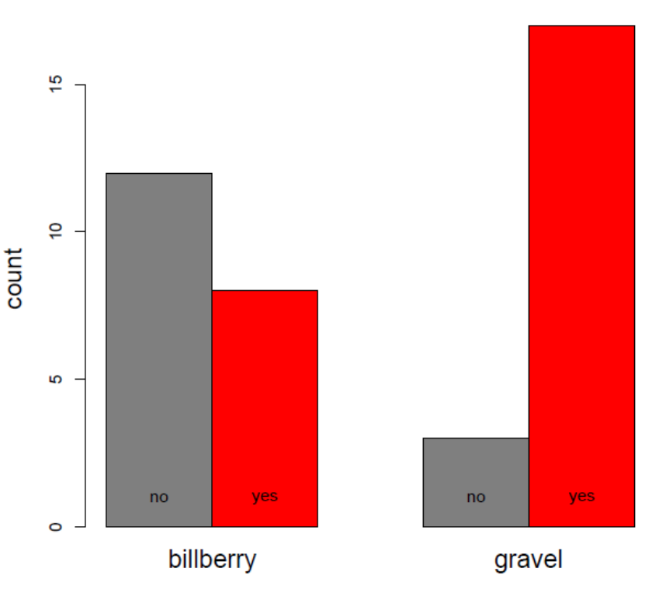
Fig. 14.1.1: Barplot of the frequencies the object was found (yes) or not (no) on two different substrates.
The question is – of course – whether these seemingly different frequencies are indeed significantly different. As in almost all statistical tests, the logic is that we start by assuming that there are no differences. This is the null hypothesis and in this case the null hypothesis implies that finding/not finding the object is assumed to be the same when searching in billberry and gravel. To compute the probability that random processes can produce the observed counts, we can conduct a chi-square test using the function chisq.test(). Conveniently, the formatting of the data in the correct format for this test has already been done as it is the same tabulation we have above. Thus, we can directly perform the test.
> #chi square
> chisq.test(data.table)

Pearson's Chi-squared test with Yates' continuity correction

data: data.table
X-squared = 6.8267, df = 1, p-value = 0.008981
This is a very short output, but it provides us with the essential information needed. What is needed to report this statistical test, and indeed the fast majority of all statistical tests are three key pieces of information:
- Test statistic (in this case the chi-square denoted X-squared)
- Degrees of freedom (abbreviated by df)
- Probability the test statistic with the associated degrees of freedom is due to chance alone (p-value)
We can hence report the finding, for example along the following lines “We tested the hypothesis that finding a bird-like object depended on the substrate under the windturbine. We find that in most (85%; 17/20) trials on gravel the object was found, whereas it was less likely to be found in billberry bushes (40%; 8/20 trials; Fig. 14.1; chi-square = 6.3, d.f. = 1; P = 0.009).” Note that we are able to make the statement “…it was less likely…” because the statistical test shows what is commonly referred to as a significant difference from the random expectation, meaning the P value is below 0.05 (5%).
If the P value was above 5% then one cannot claim there is a difference. It may look like it from the numbers, but we cannot conclude there is a difference unless we can demonstrate that the probability to obtain the observe counts are very unlikely.
By assigning the procedure to an object we can obtain more information
> #assign to object
> chisq.results<-chisq.test(data.table)
> chisq.results

Pearson's Chi-squared test with Yates' continuity correction

data: data.table
X-squared = 6.8267, df = 1, p-value = 0.008981

> str(chisq.results)
List of 9
$ statistic: Named num 6.83
..- attr(*, "names")= chr "X-squared"
$ parameter: Named int 1
..- attr(*, "names")= chr "df"
$ p.value : num 0.00898
$ method : chr "Pearson's Chi-squared test with Yates' continuity correction"
$ data.name: chr "data.table"
$ observed : int [1:2, 1:2] 12 8 3 17
..- attr(*, "dimnames")=List of 2
.. ..$ : chr [1:2] "no" "yes"
.. ..$ : chr [1:2] "billberry" "gravel"
$ expected : num [1:2, 1:2] 7.5 12.5 7.5 12.5
..- attr(*, "dimnames")=List of 2
.. ..$ : chr [1:2] "no" "yes"
.. ..$ : chr [1:2] "billberry" "gravel"
$ residuals: num [1:2, 1:2] 1.64 -1.27 -1.64 1.27
..- attr(*, "dimnames")=List of 2
.. ..$ : chr [1:2] "no" "yes"
.. ..$ : chr [1:2] "billberry" "gravel"
$ stdres : num [1:2, 1:2] 2.94 -2.94 -2.94 2.94
..- attr(*, "dimnames")=List of 2
.. ..$ : chr [1:2] "no" "yes"
.. ..$ : chr [1:2] "billberry" "gravel"
- attr(*, "class")= chr "htest"
Above code stores the result of the chi-square test in the object chisq.results. Simply calling the object chisq.results only prints out the basic summary of the chi-square test. Using the str() function, however, it becomes clear that chisq.results is an object of class list (chapter 12.2). As a rule, a statistical test will produce a list because this class can accommodate various different pieces of information (i.e. various classes) as we can see demonstrated here as well. Observe that the attr (attribute) holds additional information on some of the information contained, typically names of rows and columns. We can use the tag names to explore the output further. We can for example extract the test statistic, d.f. and P value.
> #accessing the information
> chisq.results$statistic
X-squared
6.826667
> chisq.results$parameter
df
1
> chisq.results$p.value
[1] 0.008980671
These statistics could be useful information to display in the barplot
> # write text in barplot
> mtext(paste("X-sq =",format(chisq.results$statistic,digits = 2)
+ , "df =",chisq.results$parameter
+ ,"P =",format(chisq.results$p.value,digits = 2)))
which updates the barplot we already made with the statistics of the chi-square test, now displayed at the top (Fig. 14.1.2). In adding the text the script uses the function format() to reduce the number of decimals to 2. The function paste() converts all arguments to one string, irrespective of whether they are a string (such as “X-sq”) or a number (such as chisq.results$statistic).

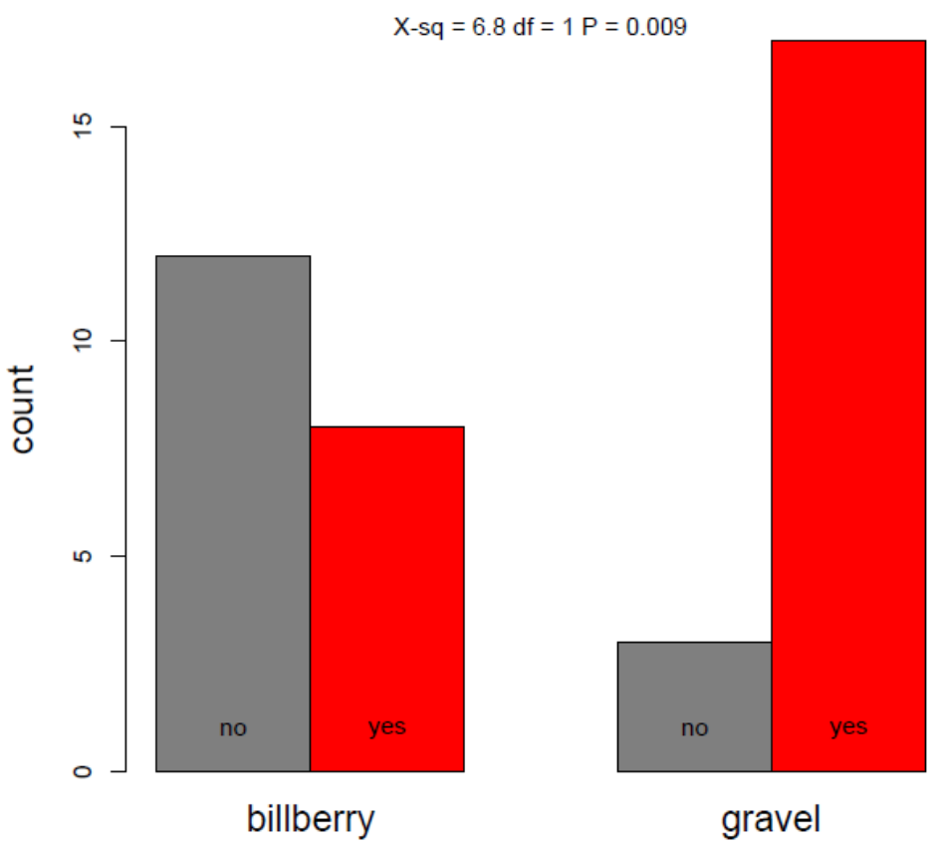
Fig. 14.1.2. Barplot of the observed counts of whether the with the chi-square test results printed.
The resultant figure contains both the data and the test statistics and would work well for example in a presentation of this work.
The chi square statistic is computed on the basis of the observed and expected values. The object chisq.results also contains these values
> chisq.results$observed
billberry gravel
no 12 3
yes 8 17
> chisq.results$expected
billberry gravel
no 7.5 7.5
yes 12.5 12.5
The expected values describe numerically what we would expect if we assume there is an equal probability to find the object either in billberry or gravel substrate. That is, under the null-hypothesis the substrate does not matter and we would expect that out of the 15 trials when the bird-like toy was not found half of them were in billberry and half in gravel. As we can see, not finding the bird-like toy was more common than expected in billberry (12 trials) than expected (7.5 trials) and less common in gravel (3) than expected (7.5). To further drive this point home, we can investigate what is termed “residuals”
> #residuals
> chisq.results$residuals
billberry gravel
no 1.643168 -1.643168
yes -1.272792 1.272792
Not finding the bird-like object was more common than expected in billberry (positive residual deviation) and finding the bird-like object was more common than expected on gravel. Clearly this pattern fits well with the way the data looks when tabulated and plotted, thereby providing additional confidence that the test was performed properly.
To sum up, a fairly generally applicable script of the above procedures would thus be:
# ------ 0. Import data from file and check the import worked:
# ------ 1. tabulate the data:
data.table<-xtabs(~found+substrate, data=data.windturbine)
data.table
# ------- 2. barplot of the tabulated data:
mids<-barplot(data.table
, beside = T
, ylab=list("count",cex=1.5)
, cex.names=1.5
, col=c("grey50","red"))
text(mids,1,rownames(data.table))
# ------- 3. perform the chi square test on the tabulated data:
chisq.results<-chisq.test(data.table)
chisq.results # test statistics printed on console
# ------- 4. test statistics added to the barplot:
mtext(paste("X-sq =",format(chisq.results$statistic,digits = 2)
, "df =",chisq.results$parameter
,"P =",format(chisq.results$p.value,digits = 2)))
# ------- 5. closer look:
# frequencies
chisq.results$observed
chisq.results$expected
#residuals
chisq.results$residuals

14.2 t-test
A t-test is used to statistically test for differences in the means of a quantitative variable between two groups. For convenience, we here define the data directly but typically you would of course read in the data from a file and perform checks that your import was successful. The work flow can be illustrated by considering the following data.frame
> massData<-data.frame(individual=c("A","B","C","D","E","F","G","H","I","J")
+ , colour= c("blue", "blue", "blue", "blue", "blue", "red", "red", "red", "red", "red")
+ , mass=c(1.0, 1.2, 1.6, 1.4, 1.5, 2.1, 1.9, 1.8, 1.9, 2.2) )
> massData
individual colour mass
1 A blue 1.0
2 B blue 1.2
3 C blue 1.6
4 D blue 1.4
5 E blue 1.5
6 F red 2.1
7 G red 1.9
8 H red 1.8
9 I red 1.9
10 J red 2.2
The data consists of two groups of individuals, blue and red ones. The question now is whether these two groups differ in their mass. Always start your analyses with graphically exploring your data. We can draw a barplot to explore the differences in mass between these two groups.
> #make a boxplot of mass for the two groups
> boxplot(mass~colour, data= massData,col=c("blue","red"))
Investigation of the plot (Fig. 14.2.1) suggests a difference in mass between red and blue individuals.
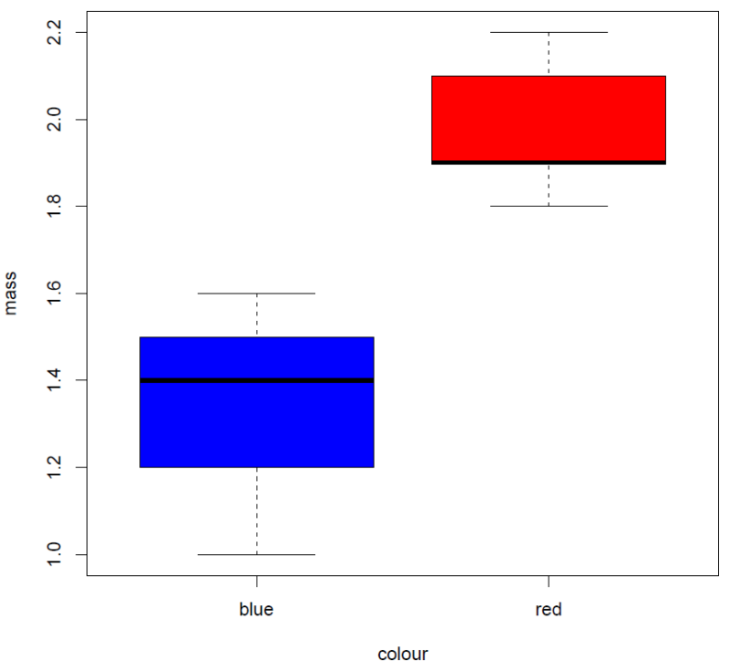
Figure 14.2.1: Box plot of mass for two groups of differently coloured individuals.

The box plot shows that median mass of blue individuals is 1.4 and 1.9 for red individuals.
Another good plot to investigate is a stripchart of the data distribution in the two groups. We can produce such a plot using the same code for the barplot but instead calling the function stripchart()
#stripchart
> stripchart(mass~colour, data= massData,col=c("blue","red"))
The stripchart (Fig. 14.2.2) plots the data points of mass for each individual per group in one figure. Note that the stripchart function in its default setting will overplot the same data. Because two red individuals have a mass of 1.9, it looks like there are only four datapoints for red individuals in Fig. 14.2.2. By specifying that method=”jitter” a small random deviation in terms of the Y-coordinate in the plotting space is added, and hence this kind of overplotting is reduced (Fig. 14.2.3).
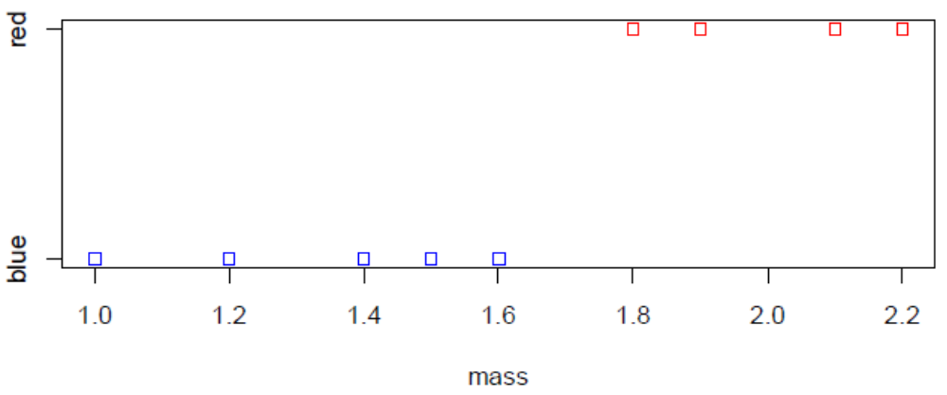
Figure 14.2.2: Stripchart plotting the mass for each individual for the two colour groups
#stripchart with jitter
> stripchart(mass~colour, data= massData, col=c("blue","red"), method=”jitter”)
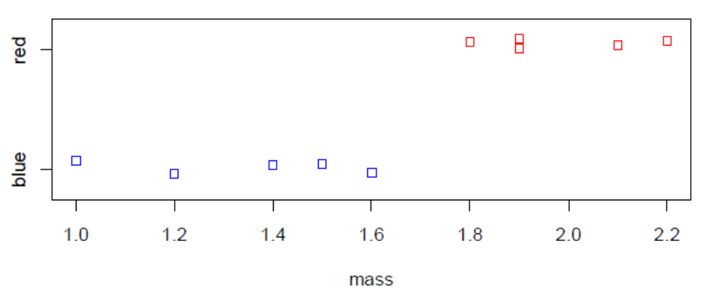
Figure 14.2.3: Stripchart of mass with a small random deviation added (argument: method=”jitter”) for the two colour groups. Datapoints of two individuals with a mass of 1.9 are here separated, but are plotted on top of each other (and hence inseparable) in Fig. 14.2.2. Note that jitter adds a small random number in terms of the Y-axis and hence the data does not align anymore when compared to Fig. 14.2.2.
Plotting the boxplots and the stripchart for the two groups is informative about their distribution. Having plotted the data it seems that the red individuals may have a larger mass than the blue individuals. Still, the data is fairly small and it may have been just by chance that the red individuals’ mass was on average larger than the mass of blue individuals. Thus, a statistical test is needed to compute the probability that differences in the means of these groups are caused by chance alone. This test is called a t-test, implemented in R with the function t.test(), and it produces the following output
> t.test(mass~colour, data=massData)

Welch Two Sample t-test

data: mass by colour
t = -4.9086, df = 7.0608, p-value = 0.001694
alternative hypothesis: true difference in means between group blue and group red is not equal to 0
95 percent confidence interval:
-0.9477716 -0.3322284
sample estimates:
mean in group blue mean in group red
1.34 1.98
Quite much information is printed. First, the heading informs us a “Welch two-sample t-test” was performed. This is a type of t-test that is robust to differences in variance between groups which otherwise is an assumption of the t-test. Thus, we do not need to be concerned about the equality of variances. Then there is a reminder that the test considers whether mass differs by colour which is indeed as was intended (always good to check). The next line provides the test result. Again, as a rule, when we report a statistical test we need to include:
- Test statistic (in this case the t-test statistic denoted t)
- Degrees of freedom (abbreviated by df)
- Probability the test statistic with the associated degrees of freedom is due to chance alone (p-value)
The output reminds us that the statistical test is carried out against a specific alternative hypothesis. Here it is good to remember that a statistical test gives the probability that the null-hypothesis is true. The null hypothesis for a statistical test is typically that any observed differences are due to chance alone, and hence that any observed differences are therefore not so-called true differences. That is, for our case, the null hypothesis is that true difference between the group means is in fact 0, but we observe differences in these means due to chance (mainly because we measured relatively few individuals). If we reject the null hypothesis we thereby accept the alternative hypothesis which is that the observed differences are inidicative of true differences between the groups. We reject the null hypothesis when the observed differences are so large that it is highly unlikely that they were caused just by chance alone. By convention, the border value for what we in science consider “highly unlikely” is 5% (P = 0.05). Thus, based on the test statistics reported (t = –4.9; d.f. = 1, P = 0.002), we would in this case reject the null hypothes (because 0.002 < 0.05) and we would thereby accept the alternative hypothesis which is that there are true differences between these two groups (i.e. the difference between the means is not 0). The output continues by specifying the 95% confidence interval for the difference between the two groups. Thus, we can say with 95% probability that the true difference in means of these groups lies between these two values. The last lines specify both the order of the groups and their means.
All of the above can be summarized in a statement to report which could be as simple as “The mass of red individuals was larger than the mass of blue individuals (t = –4.9; d.f. = 1, P = 0.002)”. Important here is that we report not only that there was a difference but also the direction of the difference (i.e. that mass of red individuals was larger than mass of blue individuals). Additional information such as group means and their standard error, or a plot (e.g. Fig. 14.2.1) can be included as further illustration. Note that we can make the statement “…was larger than…” only because we have used a statistical test to demonstrate that it is very unlikely (probability <5%) that the observed differences in mass between blue and red individuals were due to chance. If the probability would be >5% then we could not state that there was a difference.
As demonstrated in the previous chapter in some detail, we can assign the t.test() to an object and from that extract information to be printed on the barplot to produce a figure that would be instructive to use in a presentation of the work (Fig. 14.2.4).
> #make a boxplot of the data for the two groups with test stats printed
> ttest.stats<-t.test(mass~colour, data=massData)
> str(ttest.stats)
List of 10
$ statistic : Named num -4.91
..- attr(*, "names")= chr "t"
$ parameter : Named num 7.06
..- attr(*, "names")= chr "df"
$ p.value : num 0.00169
$ conf.int : num [1:2] -0.948 -0.332
..- attr(*, "conf.level")= num 0.95
$ estimate : Named num [1:2] 1.34 1.98
..- attr(*, "names")= chr [1:2] "mean in group blue" "mean in group red"
$ null.value : Named num 0
..- attr(*, "names")= chr "difference in means between group blue and group red"
$ stderr : num 0.13
$ alternative: chr "two.sided"
$ method : chr "Welch Two Sample t-test"
$ data.name : chr "mass by colour"
- attr(*, "class")= chr "htest"
> boxplot(mass~colour, data= massData,col=c("blue","red"))
> mtext(paste("t ="
+ , format(ttest.stats$statistic,digits = 2)
+ ,"; d.f. ="
+ , format(ttest.stats$parameter,digits = 2)
+ , "P ="
+ , format(ttest.stats$p.value,digits = 2)))

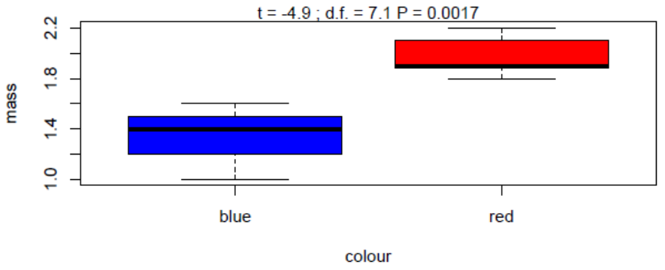
Figure 14.2.4: Boxplot of mass for blue and red individuals with the test statistics printed on top.
Summarizing the workflow of the t-test:
# ------ 0. Import data from file and check the import worked
# ------ 1. Explore the data visually:
boxplot(mass~colour, data= massData,col=c("blue","red"))
stripchart(mass~colour, data= massData, col=c("blue","red"), method=”jitter”)
# ------- 2. perform t test:
t.test(mass~colour, data=massData), beside = T
# ------- 3. barplot with test statistics added to the barplot:
ttest.stats<-t.test(mass~colour, data=massData)
boxplot(mass~colour, data= massData,col=c("blue","red"))
mtext(paste("t ="
, format(ttest.stats$statistic,digits = 2)
,"; d.f. ="
, format(ttest.stats$parameter,digits = 2)
, "; P ="
, format(ttest.stats$p.value,digits = 2)))

14.3. Linear Model
A linear model is an analysis that can tackle a variety of statistical analyses. A linear model consists of a response variable, also known as dependent variable, plus one of more explanatory variables (also known as independent variables). The model assumes that the response variable is a function of one or more of these explanatory variables. The response variable is a continuous variable. A linear model can handle both continuous and factorial explanatory variables. The linear model assumes the residuals of the model are approximately normally distributed. Residuals of a model are the deviations in the response variable between what is expected (on the basis of the model) and what is observed (i.e. your data). We encountered residuals in discussing the chi-square test above.
The linear model can be illustrated by considering made-up data on an experiment. You have picked animals from a larger population and randomly assigned them to two groups. One groups will be exposed to a treatment and the other group will be the control. Before applying the treatment, you measure the length of all individuals. When the experimental treatment has finished, you again measure their length. Data obtained are:
> data.lm<-data.frame(
+ final.length=c(10.2,10.1,12.3,9.8,7.9,8.5,9.9,11.8, 10.3,8.4,11.1,10.7,9.9,12.1)
+ , exp=c("treated", "treated", "treated", "control", "control", "control", "control"
+ ,"treated", "treated", "control", "treated", "control", "control", "treated")
+ , orig.length= c(1.8,2.1,2.3,1.8,1.9,1.6,1.9,1.8,1.9,1.7,2.1,2.0,1.9,2.0))
> data.lm
final.length exp orig.length
1 10.2 treated 1.8
2 10.1 treated 2.1
3 12.3 treated 2.3
4 9.8 control 1.8
5 7.9 control 1.9
6 8.5 control 1.6
7 9.9 control 1.9
8 11.8 treated 1.8
9 10.3 treated 1.9
10 8.4 control 1.7
11 11.1 treated 2.1
12 10.7 control 2.0
13 9.9 control 1.9
14 12.1 treated 2.0
where the final.length is the length of the individual after the experimental period, exp denotes the experimental group the individual was assigned to and hence whether it was exposed to the treatment or was a control and orig.length is the length before the treatment started. You are now interested in knowing whether the treatment affected the final length of the animal.
As always, we start by exploring the data graphically. Here the stripchart() function is useful.
> #explore the data graphically
> par(mfrow=c(2,1)
> stripchart(orig.length~exp, data=data.lm,method="jitter",col=c("red","blue"))
> stripchart(final.length~exp, data=data.lm,method="jitter",col=c("red","blue"))
which nicely shows how the data is distributed for the control and treatment groups (Fig. 14.3.1).
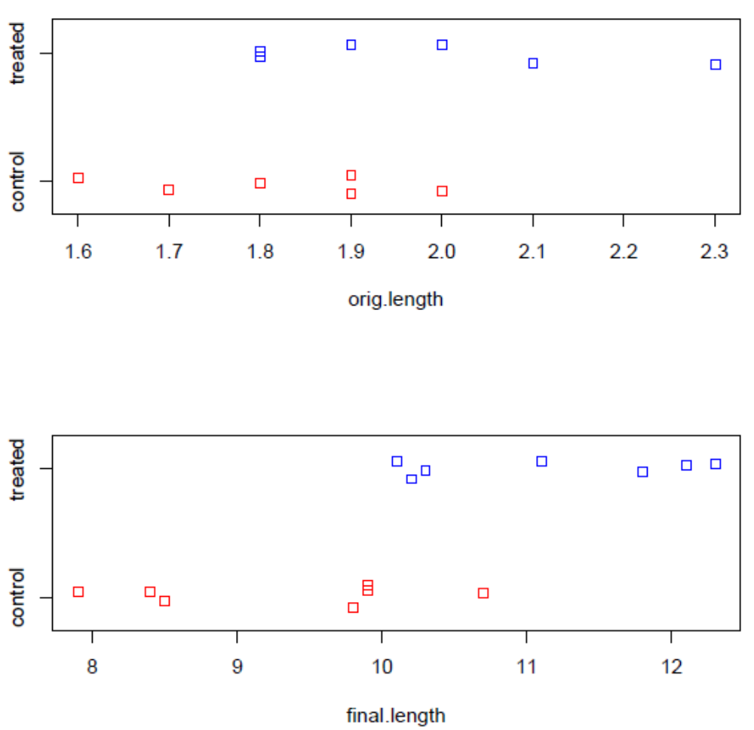
Figure 14.3.1: Stripchart plots of the both original length and final length of the individuals in control and treatment groups
It seems that the final length of individuals in the “treated” group could be larger than the length of individuals in the “control” group (lower panel in Fig 14.3.1). However, it is worrying that also the original length of these two groups appears to differ (upper panel in Fig 14.3.1). If this indeed would be the case (i.e. the difference would be statistically significant) our experiment would not be correct. Of course the “treated” animals would be longer at the end of an experiment if they already were longer at the start! Since we assigned the treatment at random there should not be a difference in length prior to the experiment. We thus quickly test whether there is a difference between the two groups with a t-test.
> t.test(orig.length~exp, data=data.lm)

Welch Two Sample t-test

data: orig.length by exp
t = -1.9817, df = 11.169, p-value = 0.07266
alternative hypothesis: true difference in means between group control and group treated is not equal to 0
95 percent confidence interval:
-0.36147187 0.01861473
sample estimates:
mean in group control mean in group treated
1.828571 2.000000
The test statistic, df and P values are t= –2.0; d.f. = 11.2, P = 0.07. Based on these statistics, we conclude that there is no difference in length of the animals prior to the start of the experiment (P = 0.07 > 0.05.
Now one option could be to simply run a t-test for the difference in final length between the two groups. Nevertheless, given that there is some indication that the lengths of the individuals before the experiment were perhaps not as equal as you would have hoped for, it is probably a good idea to take into account the original length when testing for difference in final length between the two groups. Statistically, we can do so by including original length as a so-called covariate in the analysis when testing for differences between the groups. We investigate how this would look by plotting final length as a function of original length for the two groups.
> # plot of the data with both covariate and groups
> plot(final.length~orig.length
+ , col=c("red","blue")[as.factor(data.lm$exp)]
+ , pch=19
+ , cex=1.2
+ , xlab=list("Length before experiment",cex=1.3)
+ , ylab=list("Length after experiment",cex=1.3)
+ , data=data.lm)
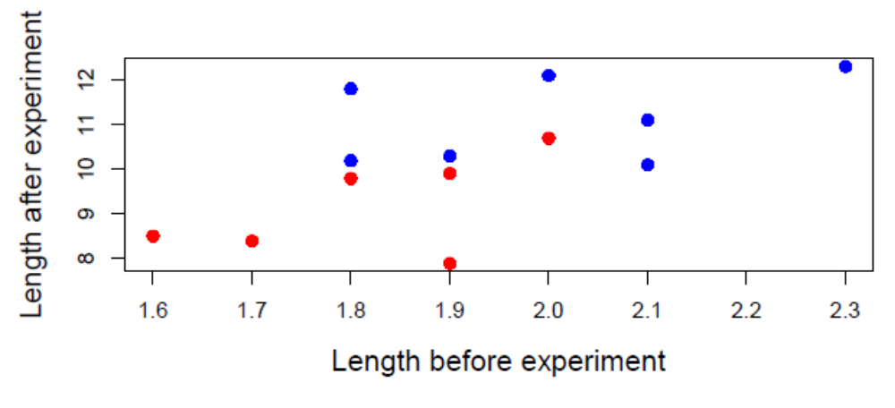
Figure 14.3.2: Plot of length after the experiment as a function of the length prior to the experiment for animals that were treated (in blue) or were control (in red).
From this plot of the data (Fig. 14.3.2) it seems that final length (i.e. length after the experiment) is associated with length before to the experiment. Again, this makes sense, if an animal was relatively large compared to others before the experiment it likely will remain relatively large. The question is, however, whether there is a difference in final length between treated animals (plotted in blue in Fig. 14.3.2) and control animals (plotted in red in Fig. 14.3.2) while taking into account their length prior to the experiment. Technically, the statistical model to explore this question is a linear model. We can implement the linear model using the function lm() and directly assign it to an object so we can obtain a summary.
> # linear model
> m1.exp<-lm(final.length~exp+orig.length,data=data.lm)
> summary(m1.exp)

Call:
lm(formula = final.length ~ exp + orig.length, data = data.lm)

Residuals:
Min 1Q Median 3Q Max
-1.60227 -0.49248 0.08458 0.53511 1.23779

Coefficients:
Estimate Std. Error t value Pr(>|t|)
(Intercept) 4.122 3.002 1.373 0.1971
exptreated 1.343 0.563 2.386 0.0361 *
orig.length 2.832 1.631 1.736 0.1104
---
Signif. codes: 0 ‘***’ 0.001 ‘**’ 0.01 ‘*’ 0.05 ‘.’ 0.1 ‘ ’ 1

Residual standard error: 0.9142 on 11 degrees of freedom
Multiple R-squared: 0.6074, Adjusted R-squared: 0.536
F-statistic: 8.509 on 2 and 11 DF, p-value: 0.005846
The summary produces a fair amount of output. It starts with reminding us of the call made. Then it reports the residuals in quartiles: minimum, 1st quartile, median = 2nd quartile, 3rd quartile, maximum. Remember that the residuals are the deviation between the observed values (the data) and the expected value on the basis of the linear model you have specified. If the model fits the data these residuals should on average be zero and if they are normally distributed the median should be equal to the mean with both negative and positive values distributed as a bell-shaped curve around them. The computation procedure of the linear model assumes that these residuals are approximately normal distributed. A quick check is hence to see if the median is around zero and the other quartiles more or less evenly around it. This looks reasonable. We will later on explore the residuals using other approaches.
The table then continues with what is arguably the most interesting part which are the coefficients. The output is tabulated such that for each explanatory variable in the model there is the estimate (Estimate), the standard error of the estimate (Std.Error) and a t-test for whether the estimate differs from zero with the t value and P value printed as t value and Pr(>|t|), repectively. The first estimate listed in the coefficient table is called (Intercept). We did not specify it in the call: Where did that come from? By default there will be an intercept in a linear model. The estimate of the intercept informs us what the final length is expected to be when all explanatory variables equal zero. As one of the covariate is the original length which is always larger than zero, this value is not easily interpreted now.
The next estimate is for exptreated which is R stating, perhaps a bit clumsily, both the name of the variable (exp) and the level (treated). Importantly, the levels are based on the variable exp being (internally) converted to a factor. As a result the estimate provided is the contrast (i.e. the difference) between control and treated. That is, the linear model concludes that that final length is 1.34 larger in treated animals compared to the control animals. This estimate of the treatment effect is statistically significantly different from zero as is evidenced by the P value being lower than 5%. The R output uses an asterisk (*) to draw attention to the estimates that differ from zero. The length of animals prior to the experiment (orig.length) is positive but the estimate is not significantly different from zero.
Below the coefficient table, the R output provides statistics on the residuals, as well as the R² of the linear model which is the proportion of variance in the data explained by the model. The last row in the output is an F test comparing this linear model with the null model or “intercept only” model. We see that the current linear model (with intercept, exp and orig.length) differs significantly from the intercept-only null-model which is good.
A number of diagnostic plots are provided using the function plot() for the object that stores the linear model
> plot(m1.exp)
Waiting to confirm page change...
Note that you need to click on the plot to produce the next plot. In total, four plots are produced (Fig. 14.3.3) and their main function is to check the residuals. The first three plots can be used to identify outliers. Outliers are data points for which the model is very poor (large residual value) and/ or which have a large influence on the model’s estimates. The latter is termed leverage. The first and third plots show the residuals as a function of the fitted values. Fitted values are the expected value for a data point given the explanatory variables measured. Thus, in our case the fitted values are the expected final length of animals based solely on their original length and whether they were in the control or treated group. For a model to be correct, there should not be a pattern in the residuals as a function of the fitted values. In plots one and three, the red line is fitted and it shows no clear pattern (i.e. not increasing or decreasing) so that is encouraging. Th second plot shows the residuals plotted against the leverage for each data point. In addition, the red dashed line plots the Cook’s distance values of 0.5 and 1. Cook’s distance is a measure of the influence of a single data point on the model estimates. Essentially, it measures how much the model estimates would change if that one point was omitted. Points that both have large residual (poor fit) and high leverage will obtain a high Cook’s distance. Values of 0.5 and 1 are plotted in the graph because you can think of these levels as “suspicious” and “should not be exceeded”, respectively. In this case, the plot looks nice. The last, fourth, plot is a Quantile-Quantile (Q-Q) plot of residuals against a normal distribution. If the residuals are perfectly normally distributed, all points are on the diagonal line in the plot. Clearly, the residuals of our linear model are nicely following the line so we are good.
In this case, the assumptions of the linear model match the data nicely. So, we can be confident the model can be trusted. What to do when the diagnostics of your linear model are not looking so nice is more complicated and outside the scope of this course.

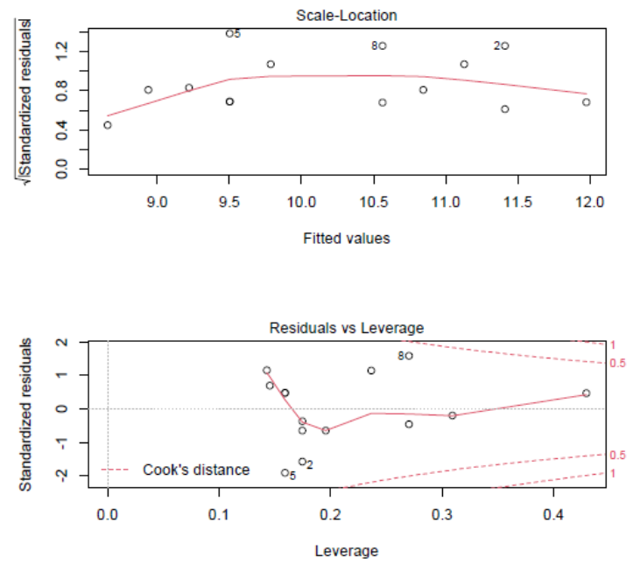
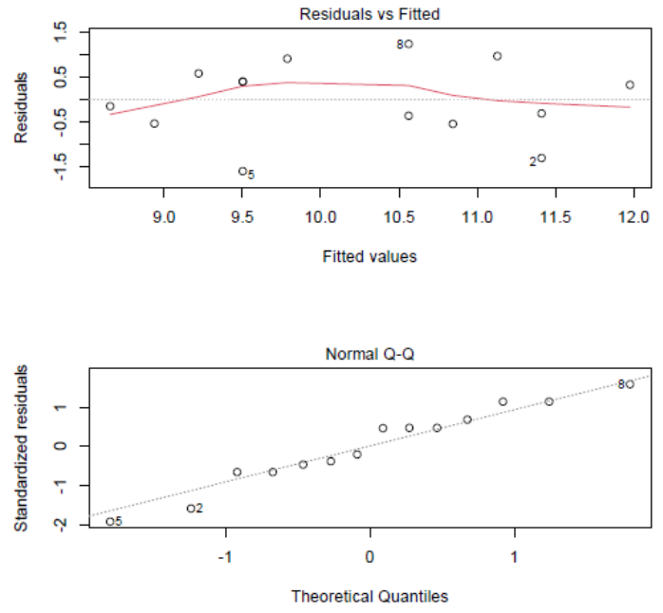
Figure 14.3.3: Diagnostic plots of a linear model. See text for details.
The summary of the linear model shows the estimates and performs a statistical test on whether the estimate differs from zero. As a rule, these tests give you a good indication of which variables are important in your linear model. Nevertheless, it is important to report the overall statistics of your model derived from an ANalysis Of VAriance (ANOVA). The function anova() produces this for the linear model
> anova(m1.exp)
Analysis of Variance Table

Response: final.length
Df Sum Sq Mean Sq F value Pr(>F)
exp 1 11.7029 11.7029 14.0017 0.003255 **
orig.length 1 2.5203 2.5203 3.0154 0.110361
Residuals 11 9.1940 0.8358
---
Signif. codes: 0 ‘***’ 0.001 ‘**’ 0.01 ‘*’ 0.05 ‘.’ 0.1 ‘ ’ 1
The above ANOVA table reports two measures of variance (Sum of Squares and Mean Squares) for each of the explanatory variables as well as the residuals. The F statistic is the ratio in the mean squares associated with an explanatory variable over the mean squares of the residuals. An F test computes the probability that the variances associated with the explanatory variables exceeds the residual variance. A good way to report the findings of a linear model is to combine the summary table and the ANOVA table (Table 14.3.1).

Table 14.3.1. Results of a linear model of the effect of treatment and length before the treatment was applied on length after the experiment. Reported are for each explanatory variable its estimate with standard error (SE), as well as an F test with associated degrees of freedom and P value.
–––––––––––––––––––––––––––––––––––––––––––––––––––––––––
Effect Estimate ± SE test P
–––––––––––––––––––––––––––––––––––––––––––––––––––––––––
Intercept 4.1 ± 3.0
Treatment 1.3 ± 0.6 F_{1,11} = 14.0 0.003
Length before experiment 2.8 ± 1.6 F_{1,11} = 3.0 0.11
––––––––––––––––––––––––––––––––––––––––––––––––––––––––––

When reporting the results in this way (Table 14.3.1), only the coefficients (as produced by summary()) are reported, but not the test for the coefficients. The test reported in Table 14.3.1 is the F test produced by anova(). Remember that the table caption must explain clearly what is in the table. When you report on an F test, be sure to include both degrees of freedom in the order of the effect and the residuals (1 and 11 respectively, in this case). It is standard practice to place the degrees of freedom in subscript. An expanded version of this table would include also the mean squares, but this is not needed.
An alternative that is useful especially when the analysis does not include many variables is to report the results not in a separate table but directly within the text where you report the results. For example, we could describe the above analyses as “We tested whether the treatment affected the length of the animals while taking into account their length before the experimental treatment. We found that the treated animals were on average indeed longer (1.3 ± 0.6 (s.e.); F_{1,11} = 14.0; P = 0.003) compared to control animals. As we expected, animals that were longer before the start of experiment tended to also be longer after the experiment (slope was 2.8 ± 1.6 (s.e.) ; F_{1,11} = 3.0; P = 0.11).”
For a graphical presentation of the results, we can go back to the original plot of the data (Fig. 14.3.2) and add the model output to this graph. One easy way is to use the function predict() to predict the model-inferred value for each data point (i.e. the fitted value). Below we first run the lines again for the plot. We then add the model predictions directly as a new column to the data and use the function lines() to add the lines to the plot
> # plot again the data with both covariate and groups
> plot(final.length~orig.length
+ , col=c("red","blue")[as.factor(data.lm$exp)]
+ , pch=19
+ , cex=1.2
+ , xlab=list("Length before experiment",cex=1.3)
+ , ylab=list("Length after experiment",cex=1.3)
+ , data=data.lm)
> #draw the model
> #1. add the predicted values to the data.frame
> data.lm$predictions<-predict(m1.exp)
> #2. add line for the control subset
> lines(predictions~orig.length,data = subset(data.lm,exp=="control"),col="red")
> #3. add line for the treated subset
> lines(predictions~orig.length,data = subset(data.lm,exp=="treated"),col="blue")
We now produce a plot with both the data and the model prediction showing both how final length is expected to be higher for animals with a greater length prior to the experiment (lines) as well as the difference between control and treated groups (Fig. 14.3.4). Because we here use the predictions, the lines are drawn over the data range for each group. This kind of plot would work well in a presentation of the work.
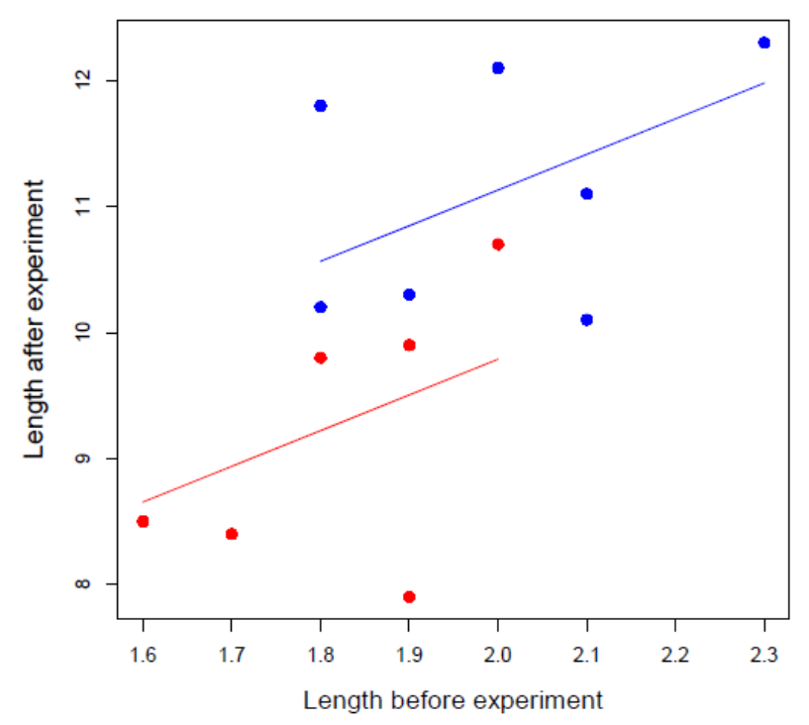
Figure 14.3.4: Length after the experimental period as a function of the length before the start of the experiment for animals that were treated (in blue) or were control (in red). Lines show the predictions of a linear model including the effect of treatment with the length before the experiment as a covariate.

14.4 Standardisation of effect sizes
In an analysis that includes one or more explanatory variables that are continuous, it is clever to scale these continuous variables to have a mean of zero and to be expressed in units of the SD of the variable. This is the so-called Z-score and it means the variable becomes dimensionless. For example, consider the data on the mass of 3 humans: 70kg, 80kg, 90kg. The mean is 80kg and the SD 10kg. The Z-score (or scaled) values are then -1, 0, +1 respectively. You can readily scale the values in the data using the function scale(). For the example above:
> #standardisation
> mass.dat<-c(70,80,90)
> mean(mass.dat)
[1] 80
> sd(mass.dat)
[1] 10
> scale(mass.dat)
[,1]
[1,] -1
[2,] 0
[3,] 1
attr(,"scaled:center")
[1] 80
attr(,"scaled:scale")
[1] 10
The output shows that scale()transforms the data and provides both the mean (“scaled:center”) and standard deviation (“scaled:scale”) as attributes. We can thus easily scale a continuous variable to have a mean of zero and to be expressed in units of its standard deviation. In practice, the scaled variable can be added as an extra column in the data.frame. For example for the data in chapter 14.3
> #standardisation
> data.lm$orig.length.stand<-scale(data.lm$orig.length)[,1]
> summary(data.lm)
final.length exp orig.length predictions orig.length.stand
Min. : 7.900 Length:14 Min. :1.600 Min. : 8.653 Min. :-1.75450
1st Qu.: 9.825 Class :character 1st Qu.:1.800 1st Qu.: 9.502 1st Qu.:-0.63800
Median :10.150 Mode :character Median :1.900 Median :10.174 Median :-0.07975
Mean :10.214 Mean :1.914 Mean :10.214 Mean : 0.00000
3rd Qu.:11.000 3rd Qu.:2.000 3rd Qu.:11.058 3rd Qu.: 0.47850
Max. :12.300 Max. :2.300 Max. :11.978 Max. : 2.15325
We can then repeat the linear model analysis but using the scaled covariate
> #m1 with sscaled covariate
> m1.exp.stand<-lm(final.length~exp+orig.length.stand,data=data.lm)
> summary(m1.exp.stand)

Call:
lm(formula = final.length ~ exp + orig.length.stand, data = data.lm)

Residuals:
Min 1Q Median 3Q Max
-1.60227 -0.49248 0.08458 0.53511 1.23779

Coefficients:
Estimate Std. Error t value Pr(>|t|)
(Intercept) 9.5427 0.3727 25.601 3.73e-11 ***
exptreated 1.3431 0.5630 2.386 0.0361 *
orig.length.stand 0.5073 0.2921 1.736 0.1104
---
Signif. codes: 0 ‘***’ 0.001 ‘**’ 0.01 ‘*’ 0.05 ‘.’ 0.1 ‘ ’ 1

Residual standard error: 0.9142 on 11 degrees of freedom
Multiple R-squared: 0.6074, Adjusted R-squared: 0.536
F-statistic: 8.509 on 2 and 11 DF, p-value: 0.005846

> anova(m1.exp.stand)
Analysis of Variance Table

Response: final.length
Df Sum Sq Mean Sq F value Pr(>F)
exp 1 11.7029 11.7029 14.0017 0.003255 **
orig.length.stand 1 2.5203 2.5203 3.0154 0.110361
Residuals 11 9.1940 0.8358
---
Signif. codes: 0 ‘***’ 0.001 ‘**’ 0.01 ‘*’ 0.05 ‘.’ 0.1 ‘ ’ 1
The covariate original length is now standardized. The estimates of the linear model are now standardized estimates. Commercial software often reports these so-called standardized coefficients in their model output by default, but in R we need to do this standardization ourselves. At first glance this standardisation has changed little. Certainly all the test statistics and P values are the same. However, comparison with the summary table in chapter 14.3 shows that standardization has changed the estimate for the intercept (was 4.1, now is 9.5) as well as the estimate for the slope of final length as a function of original length (was 2.8, now is 0.5). The estimate for the effect of the treatment has not changed. To better understand why the standardization changes these estimates it is instructive to plot again the data and the model (Fig. 14.4.1). The script to produce the plot is:
> #plot the data and model with standardised coefficients
> # plot the data with both covariate and groups
> plot(final.length~orig.length.stand
+ , col=c("red","blue")[as.factor(data.lm$exp)]
+ , pch=19
+ , cex=1.2
+ , xlab=list("Length before experiment (Z-score)",cex=1.3)
+ , ylab=list("Length after experiment",cex=1.3)
+ , data=data.lm)
> #draw the model
> #1. add the predicted values to the data.frame
> data.lm$predictions.stand<-predict(m1.exp.stand)
> #2. add line for the control subset
> lines(predictions.stand~orig.length.stand,data = subset(data.lm,exp=="control"),col="red")
> #3. add line for the treated subset
> lines(predictions.stand~orig.length.stand,data = subset(data.lm,exp=="treated"),col="blue")
> #4. add vertical dashed line at X=0
> abline(v=0,lty="dashed")
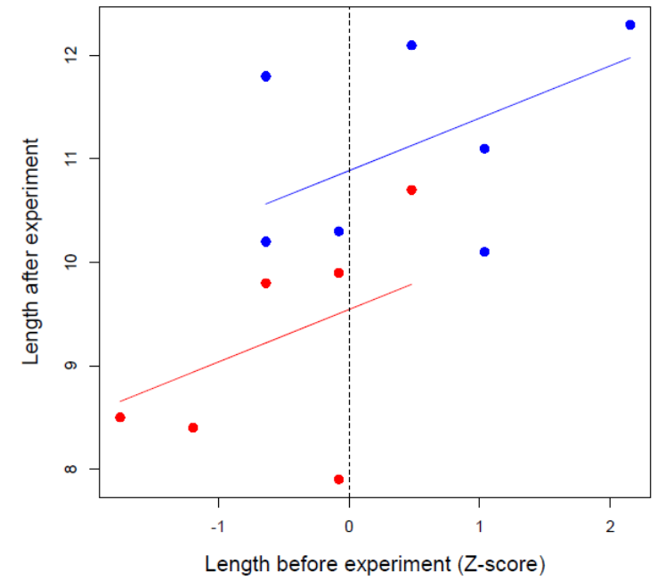
Figure 14.4.1: Plot of final length as a function of scaled length before the experiment for control (in red) and treated (in blue) animals. Lines show the model predictions
In the model with standardized coefficients the estimate of the intercept is the expected final length of the control group (9.54; intersection of the dashed vertical line and the red line in Fig. 14.4.1). The intercept of the linear model is the expected value of the response variable when all explanatory variables are zero. Because we have scaled the original length, the value “0” is now the mean original length and it lies in the middle of the data (dashed line in Fig. 14.4.1). As a result, the estimate of the intercept becomes interpretable. We can now also better understand the effect size of the treatment: From the summary table we can deduce that the treatment increases the expected final size for animals of average original length from 9.54 to 10.88 (9.54 + 1.34). Graphically, the expected final length of treated animals that were of average original length can be understood as the intersection of the blue line with the vertical dashed line in Fig. 14.4.1.
To make life even easier, we can run the linear model without the intercept, in which case the output becomes:
> summary(m1.exp.stand.no.intercept)

Call:
lm(formula = final.length ~ -1 + exp + orig.length.stand, data = data.lm)

Residuals:
Min 1Q Median 3Q Max
-1.60227 -0.49248 0.08458 0.53511 1.23779

Coefficients:
Estimate Std. Error t value Pr(>|t|)
expcontrol 9.5427 0.3727 25.601 3.73e-11 ***
exptreated 10.8858 0.3727 29.204 8.93e-12 ***
orig.length.stand 0.5073 0.2921 1.736 0.11
---
Signif. codes: 0 ‘***’ 0.001 ‘**’ 0.01 ‘*’ 0.05 ‘.’ 0.1 ‘ ’ 1

Residual standard error: 0.9142 on 11 degrees of freedom
Multiple R-squared: 0.9938, Adjusted R-squared: 0.9921
F-statistic: 588.2 on 3 and 11 DF, p-value: 2.022e-12
In absence of an intercept the linear model will now specify the expected final length when all other explanatory variables are zero for each level of the explanatory variable exp. Thus, in this formulation of the model, the estimate for expcontrol gives the expected final length for control animals and the estimate for exptreated gives the expected final length for treated animals for animals of mean original length (since original length was scaled to zero mean). Indeed, these are the values in the plot (Fig. 14.4.1). Remember that the test statistics that summary() provides is testing whether the estimate differs from zero. In the model without the intercept, this test is not very informative. The highly significant tests for expcontrol and exptreated only inform us that the final length of the control and treated animals are significantly greater than zero which is not surprising. Importantly, removal of the intercept is only informative in the case all continuous variables are scaled. As the values are now interpretable, we can make a statement like “the treatment increased the final length of animals by 14%; from 9.54 (control) to 10.9 (treated) for an animal of average original length.” We can also update the results table (Table 14.4.1)
Table 14.4.1. Results of a linear model of the effect of treatment and length before the treatment was applied on length after the experiment. Length before the experiment was standardized to zero mean and unit SD. The effect of the treatment is the contrast relative to the intercept. Reported are for each explanatory variable its estimate with standard error (SE), as well as an F test with associated degrees of freedom and P value.
–––––––––––––––––––––––––––––––––––––––––––––––––––––––––
Effect Estimate ± SE test P
–––––––––––––––––––––––––––––––––––––––––––––––––––––––––
Intercept 9.5 ± 0.4
Treatment 1.3 ± 0.6 F_{1,11} = 14.0 0.003
Length before experiment 0.5 ± 0.3 F_{1,11} = 3.0 0.11
––––––––––––––––––––––––––––––––––––––––––––––––––––––––––
There are a number of other advantages associated with standardizing, especially when there are multiple explanatory variables and interactions between explanatory varables. It is hence good to be aware how to standardize your variables.

14.5 Exercises part VI

VI.1
Heritability (h²) of a trait can be estimated by offspring-parent regression. To estimate heritability, you perform a linear model of the Z-score of mean offspring trait values on the Z-score of mean parent trait values. A Z-score is the value standardized to zero mean and unit SD, as explained in chapter 14.4. The heritability is the slope coefficient in such a linear model.
Use data of wing length collected on fruit flies. Data on offspring is provided in the file “OffspringData.csv” and data on adults in “AdultData.csv”. The variable “BroodID” identifies which offspring were in the same brood and which were the parents of that brood. Compute the heritability and provide an informative plot. Your script must contain the following steps provided in annotation below:
# reading in the data and check it
# compute the mean wing.length for offspring in each brood
# merge the two datasets of offspring and parents
# transform the data on mean tarsus of offspring and parents to Z-scores
# graphically explore your data
# implement the linear model and check the analysis is done properly
# plot the data that went into the analysis as well as the results of the analysis. Use the function abline() where the arguments for abline() are the value of the intercept (argument a) and the slope (argument b). Both these values you can extract from the summary output of the linear model by coding (use str() to see where they are)

In the end, you should produce something like:
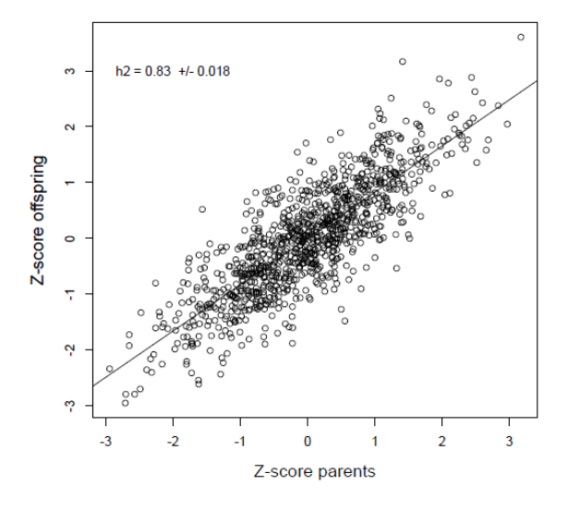

VI.2
The datafile "Koskenpato_etal_data_citizen_science.csv" can be found in Moodle. Data is from https://datadryad.org/stash/dataset/doi:10.5061/dryad.q573n5tf5
and contains data collected in a citizen science game where participants were shown pictures of stuffed tawny owls of two different colour morphs (Brown or Grey) in different landscapes (with snow and without snow). Participant had a certain amount of time to click on the tawny owl in the picture and if they managed to do so, the owl was considered to have been found. The data contains several variables, but for this exercise the most important ones are
Found: Yes (owl was found within the time limit); No (owl not found within the time limit)
Snow: TRUE if there was snow in the picture; FALSE if there was no snow
Colour: colour morph of the stuffed tawny owl in the picture (Brown or Grey)

Read in the data, perform checks and plotting and conduct a chi-square test for whether the two colour morphs differ in probability to be spotted when there is snow. The result should be as summarized in the graph below.

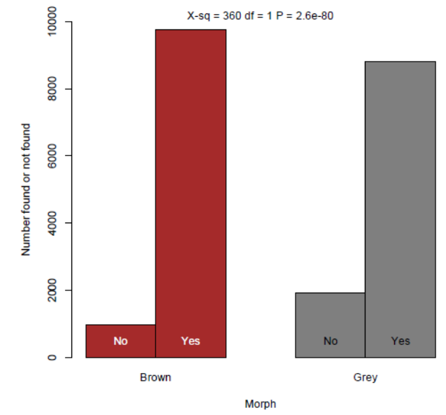
Write a short statement as annotation at the end of your script on how you would report this result on the basis of the test you performed.
Note that this analysis is meant to be an explorative analysis of the data. It is not the final analysis of the data which would need to take into account a number of other aspects imposed by the design of the study. Thus, a more statistically rigorous result is required. However, this kind of explorative analyses are useful to get a feel of the data.

VI.3
The data “Growthdata.csv” which you can find in Moodle contains information on the growth of 1000 plant individuals that were either growing under standard conditions (treat = “control”) or were exposed to a treatment (treat = “treated”). Did the growth differ between these groups? Code the whole workflow, from reading in the data to producing good summary graphs of the results with statistics in it.

VI.4
R has a number of datasets that can be used to explore various models. The datasets can be loaded using the function data()
- Load the dataset “Chickweight” and provide a check the data was read correctly.
The data contains weight of chicks that were fed different diets, where weights were measured at different times during growth.
- Create a new data.frame that contains only information on the final weight of the chicks (i.e. weight measured at the last time step)
- Code the workflow for analysis of whether the final weight differ between the diets. Not just the test, but also figures to explore the data and a good summary graph with the statistics in it.

VI.5
The file “TreeData.csv” contain information on the girth (=diameter), volume and habitat type of trees. Do the trees in the two habitats differ in their volume while taking into account their girth? This is a linear model. Code the entire workflow including a check for reading in the data, explorative graphs, linear model, and a final presentation-ready figure showing the model results.

